HOTEL MANAGEMENT SYSTEM

SUBMITTED BY- NAUSHAD AHMAD KAJAL NIRMAL GUPTA SHITAL KALMATKAR

MADHUBALAN DEVENDRA PRATEEKSHA KAMBLE

# Hibernate Mapping

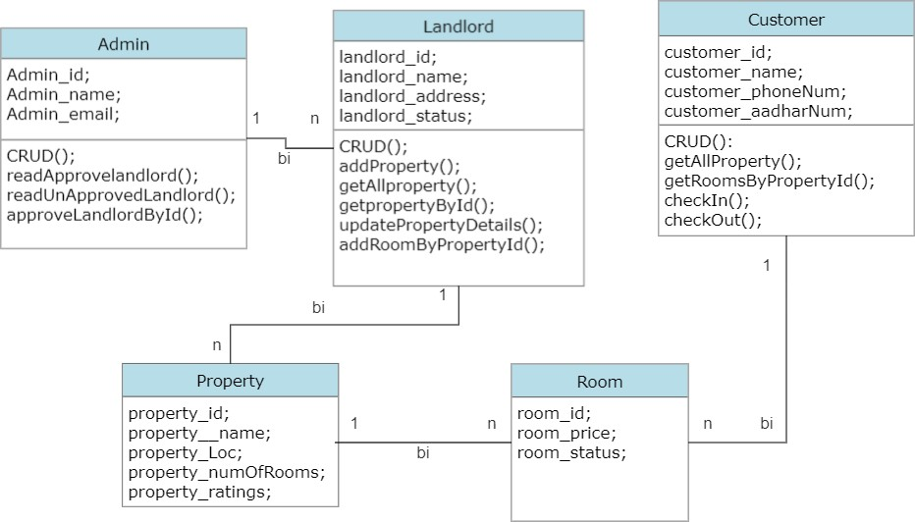

Hotel Management System

We have designed and referred the above Class flow chart to make the project on the management of hotel.

Classes in the project

Admin

Landlord

Property

Room

Customer

Admin Class-

# Description

-Admin will manage the landlord , he will look after the landlord approval.

-Admin is mapped by landlords using One_to_Many_Bi directional mapping.

-Until the admin approves the landlord, the landlord will not be able to do any operations .

-Only admin is capable of :

The landlords can only be approved by the admin by using method [approveLandlordById()].

Admin can get all the approved landlord by using [readApprovedLandlord()] method.

Admin can also read all the unapproved landlords by using [readUnapprovedLandlord()] method.

Landlord Class-

-Landlord will look after the property's i.e, he can add property,add rooms in the property, update the property,etc.

-Landlord is mapped by the property's using One_to_Many_Bi directional mapping.

-Landlord will only be able to perform any of these operations if the landlord is approved.

-Operations performed by landlord:

Adding the property by using [addProperty()] method.

Can get all the property by using [getAllProperty()] method.

Landlord can make the updation in the property by using [updatePropertyDetails()] method .

Landlord can add room in the property by property I'd by using [addRoomByPropertyId()] method.

Property Class-

-Property is managed by the landlord , landlord is going to look after the property's states.

-Property is mapped by the rooms using One_to_Many_Bi directional mapping.

Room Class-

-Room is managed by the landlord , landlord is going to look after the room's states(room I'd,room status ,room price ).

-Rooms is mapped by the customer using Many_to_One_Bi directional mapping.

Customer Class-

-Customer has the states, that are customer I'd

,name ,phone no.,aadhar no., all these information which are taken during the booking as soon as the details are recorded:

Customer can get the access of all the approved

properties of landlord by using [getAllProperty()] method.

After accessing the property, customer can book the available rooms in whichever property he wants to ,with the property I'd by using [getRoomByPropertyId()] method.

As soon as the customer books the room's he will be checked in that room I'd by which the room status will be updated to booked , it will not be available for booking for any other customer.

When the customer will checkout from the property the room status will be updated to available so that any other customer can book by checking the availability.